
2011 ERIC HOFFER Award for Legacy Fiction
Titles in this category are fiction books over two years of age and held particular relevance to any subject matter or art form. Unlike many in the industry, we think good books last longer than one season.
Winner
Flying Boats & Spies, A Nick Grant Adventure by Jamie Dodson, OnStage Publishing - Dodson pulls the reader in during the first sentence and never lets go. This is the first book in a three-part series, and while Flying Boats & Spies is written as an adventure novel for young boys, it is suitable and enjoyable for older children and adults. Nick Grant, a tall, bright sixteen-year-old, wants to become a pilot during the Great Depression. He works at his local airport trading hours for flying lessons. His life is forever changed when Charles and Ann Morrow Lindbergh land at the airport where he works and Ann Lindbergh gives him a package to deliver. He finds himself catapulted into a world of adventure. This enterprising young man masquerades as a high school graduate and joins the crew of a tramp steamer, only to find himself sailing from the West Coast across the Pacific, preparing the way building landing areas for the Pan Am Clipper to open the Pacific to shipping and air travel. All through the book, the foreshadowing events prior to World War II happen all around him. Dodson meticulously researched this masterpiece and delivers a novel most writers would give their eye teeth to write. This book is highly recommended, especially for readers interested in learning more about the time period. http://www.theusreview.com/USRhoffer.html#lfic
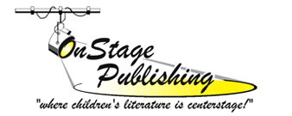
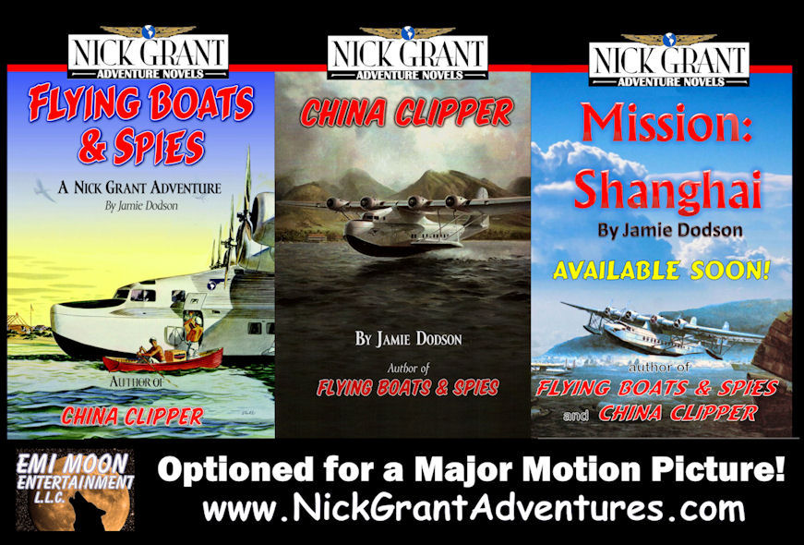 www.onstagepublishing.com

